1. NUnit-Handson(Mandatory Hands On)
Exercise 1: TestFixture & Test : (CalcLibrary Application)
CalculatorTest.cs:
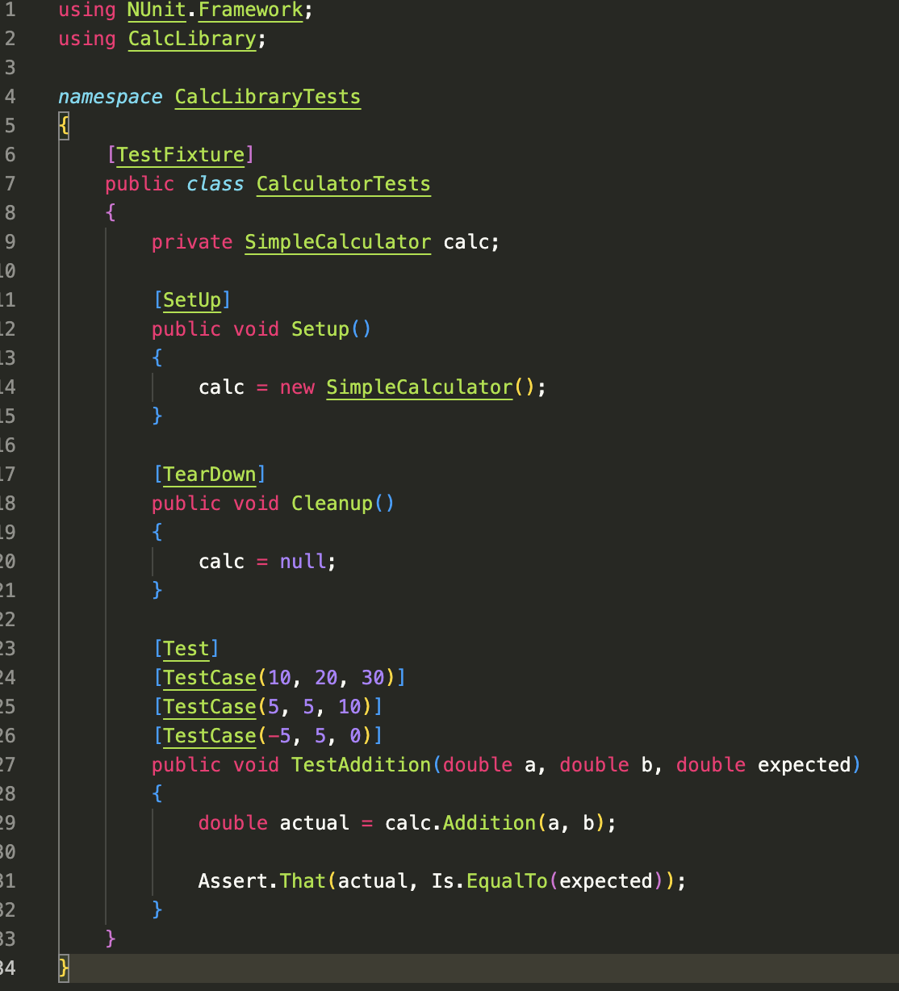

OUTPUT:
